Integrate hue with open ldap server

Hue is webbased tool to manage users and groups and by defaults its internal authenticated.

This one required backend database.

One more point,

While adding hue service, first we need to add dependency service that is oozie.

After that you can add hue service.

Hue service web port is 8888

Now I installed already ldap server.

And also I added oozie service.

Now I am installing hue database hue user and hue password.

Commands:

mysql>

mysql> create database hue;

Query OK, 1 row affected (0.00 sec)

mysql> create user 'hue'@'%' identified by 'hue';

Query OK, 0 rows affected (0.00 sec)

mysql> grant all privileges on hue.\* to 'hue'@'%';

Query OK, 0 rows affected (0.00 sec)

mysql> flush privileges;

Query OK, 0 rows affected (0.00 sec)

mysql>

screenshot:

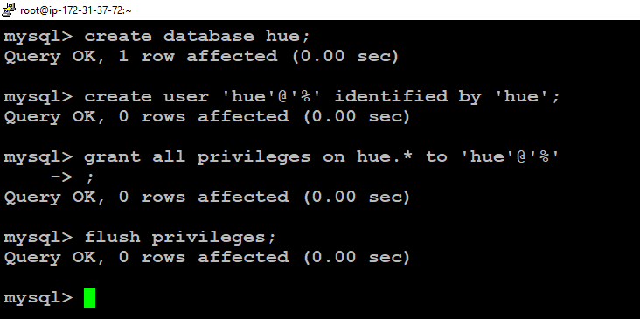

Now

After that go to clouder amangaer

And click on ur cluster and click on add service

And it will ask to select hue server and hue load balancer.

Provide the host and everything

And then after that click next click next finished.

After that.

Click on hue service there we will be having hue server web ui

Open it it will come like below window.

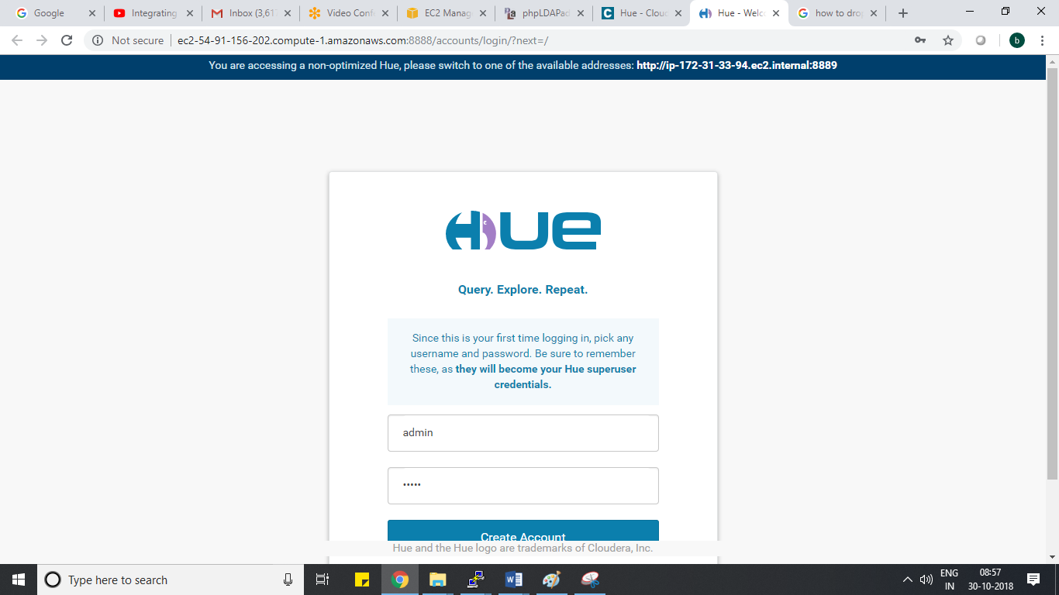

Provide the user name and password as admin and admin

For testing purpose.

Now go to hue service – click on configure tab

Search for authentication backend

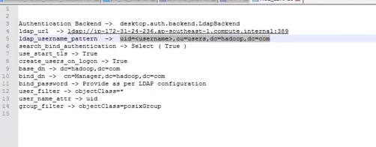

I have configured ldap details like below.

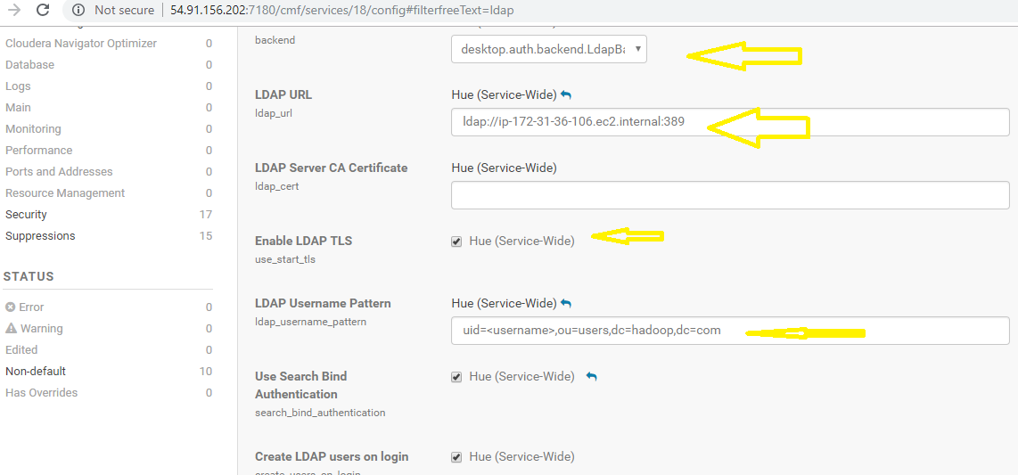

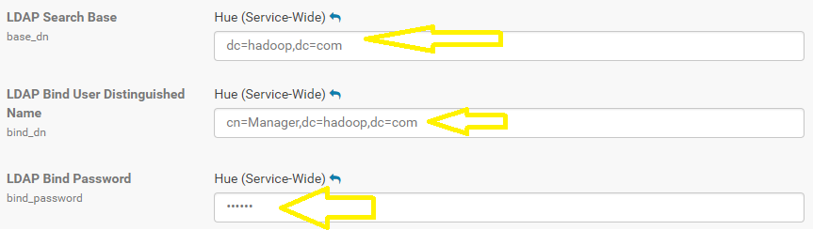

After that wha happens is,

If users are part of openldap that is phpldapadmin obviously those users can access to hue web application by providinguser name and password.

If those users are not part of ldap group they will get error saying invalid user and password.

I used user which is part of ldap server, users group. That is bgadi, skandimalla, jmedha

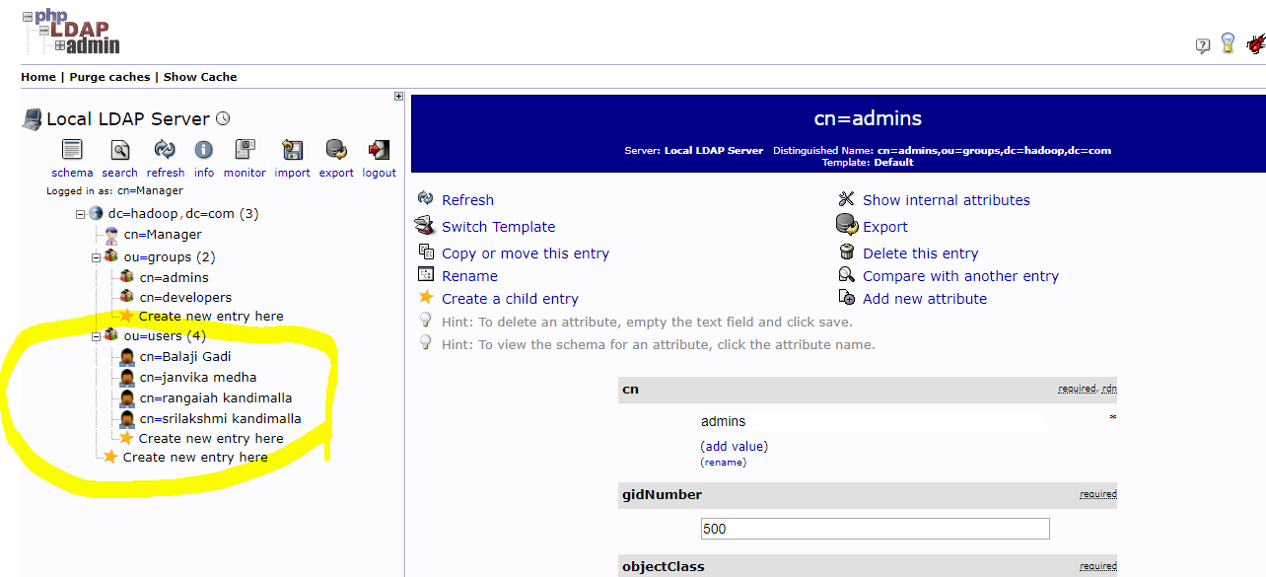

After that what I did is

I went hue service, click on web ui and given this user bgadi and password as bgadi. He is able to access hue and also in hdfs this user will be created with hdfs dfs –ls /user/bgadi

See the below screenshots.

I have given user name as bgadi and password as bgadi

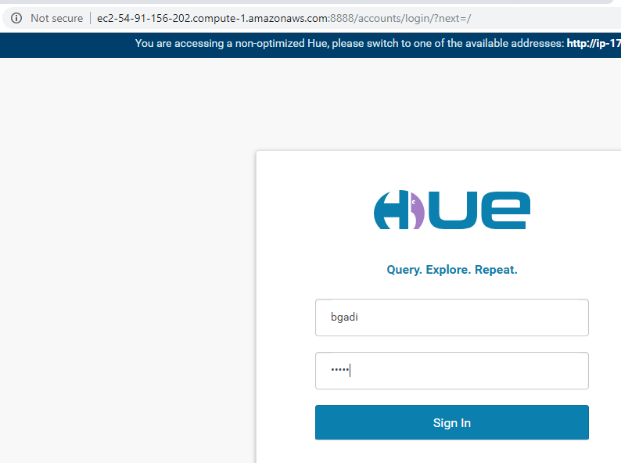

See user bgadi is able to login since this user is part of ldapgroup now.

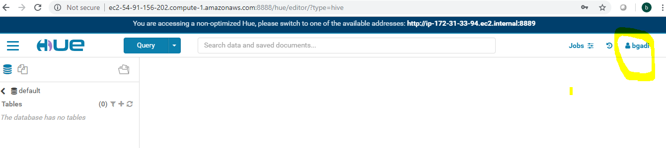

After that, this user will be created in hdfs like below. hdfs dfs –ls /user/bgadi

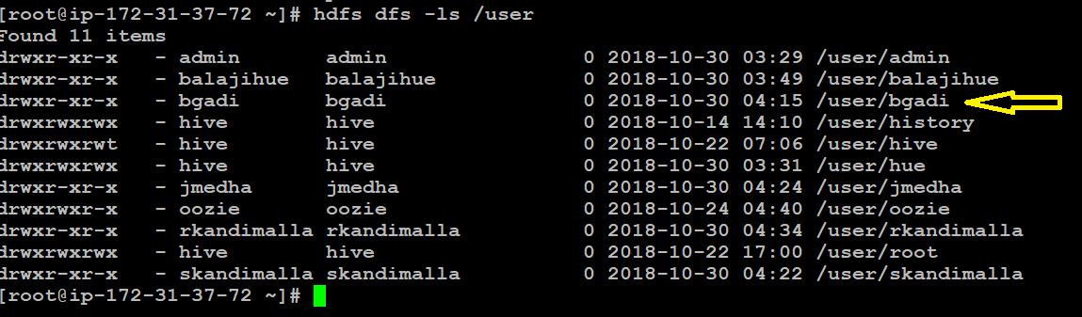

With this I can conclude that hue is successfully integrated with ldap.